NOTICE OF VACANCY
IN OFFICE OF COUNCILLOR

NACTON PARISH COUNCIL

NOTICE IS HEREBY GIVEN

that due to the resignation of Councillor Ros Eaton, a vacancy has arisen in the Office of Councillor for the Parish Council.

- A by-election to fill the vacancy will be held if ten electors for the parish give notice in writing claiming such an election to the Returning Officer not later than

02 September 2022

- The Addresses of the Returning Officer are:

Riverside  4 Canning Road Lowestoft  NR33 0EQ | Council Offices East Suffolk House Station Road Melton Woodbridge  IP12 1RT

- If no such notice is given the Parish Council will fill the vacancy by co-option.
Dated: 12 August 2022 Signed: ………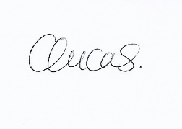……………………….
Clerk

Mrs Clare Lucas
Clerk to Nacton Parish Council 17 George Elliston Road Ipswich
Suffolk IP3 8XQ

Printed and Published by the Returning Officer, East Suffolk Council

