Orwell Park School 2021-22

Report for Annual Parish Meeting
The School has 270 pupils, all of whom are enjoying a Summer term without covid restrictions for the first time in two years. We are now running nearly all of our trips and activities and this term Year 7 will be travelling to Normandy for a week and Year 8 will embark on their annual leavers’ trip to the Ardèche after their Common Entrance exams in June. Boarding numbers have returned to pre-covid levels, with 44 full boarders and a high percentage of pupils between Years 3 and 8 boarding at least once a week.
Last year all our Year 8 pupils once again passed Common Entrance and achieved entry to their senior schools and this year 24 scholarships have been achieved so far to a wide variety of local and national senior schools, including Brighton College and Marlborough College. For the first time in quite a while we have one pupil going to Eastbourne College and one to Westminster School. This term Evie Morgan in Year 6 came first in the Classical Association National Creative Essay Competition in the aged 11 and under category.
We continue to learn from our experiences of Covid and live streaming and recording of school events are now the norm. We are also developing our STEM provision and David Horton, our Head of Digital Strategy, spends Thursday afternoons building a kit car with some of our senior pupils. Zoom lessons and online learning also gave us the opportunity to invite experts from all over the world into the online classroom. The same was true for the weekly Orangery Lectures and we were delighted to welcome speakers such as Terry Waite via Zoom to our lecture series.
Sport has continued to thrive in the last year and children have been delighted to get back to competitive fixtures and tournaments. One significant development this year has been the introduction of girls’ rugby and the senior girls were delighted to win all their games at the festival at Lord Wandsworth College last term. Cricket is the order of the day for all boys and girls this term, but we are also delighted that our equestrian team has made it to the Nationals at Hickstead.
There has been a real excitement around the creative arts, with new Head of Drama, Darren Boddice, staging a spectacular senior play Shrek the Musical and many pupils signing up for lessons with our new Speech and Drama teacher, Georgie Ross. Music has been taken to a new level under the stewardship of Director of Music, Tom Stapleton, and the Autumn and Spring Concerts were of a very high standard. The Chapel Choir now performs every two weeks in St Martin’s Church in the services led by Rev Canon Ian Wilson and there was much excitement at the arrival of Choir robes at the start of term.
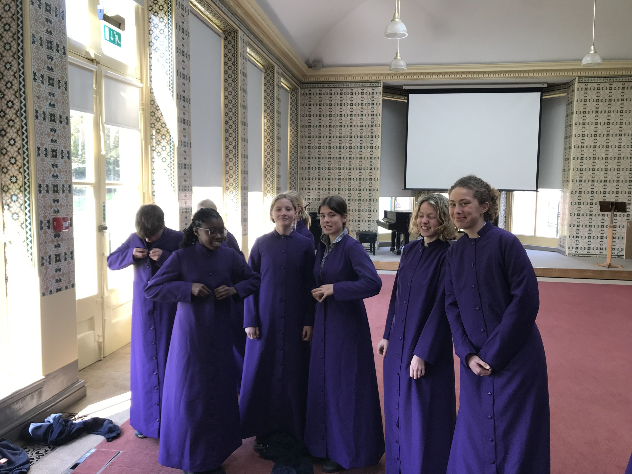
Art Exhibitions have returned to the Alston Room and parents and pupils have been able to enjoy the work of this year’s Year 8 Art and Design scholars.

We are making more use of the special facilities at Orwell Park. The woodland is regularly used for Forest School activities and camping and bushcraft with our older pupils as part of the OPS Challenge programme. This summer a new teambuilding area is being installed inside the assault course and this will help to develop the leadership skills that we value in our pupils.
Thanks to funding from the National Lottery Heritage Fund, we have initiated repairs to parts of the observatory and we have reintroduced an astronomy club for pupils in conjunction with OASI. Our three charities this year are Suffolk Young People’s Health Project (local), Barnado’s (national) and Save the Rhino (international) and the pupils have been raising money through events such as the Christmas Fayre earlier in the year. Last term we also raised money for the Disasters Emergency Committee Ukraine Appeal; all our thoughts and best wishes continue to be with everyone affected and this term we welcome to the School three Ukrainian brothers, who are staying with one of our families.
We continue to invest a significant amount of school funds into means tested bursaries and have set up the Wilkinson Spurgeon Bursary Fund to create more opportunities for children who would otherwise not be able to benefit from an Orwell Park education.
We also continue to develop our relationship with Community Interest Company, PLOT, which has been based on our site since September 2020, using the Buck House and the area of land leading down to the foreshore alongside the boundary wall. PLOT works with vulnerable children to help them reintegrate into mainstream education.
We are keen to establish greater links with the local community and with Nacton Primary School and I hope to follow up with relevant parties. Our thanks to Paula Warner and Judith Wyndham for their support as the School’s Independent Listeners.
There have been many challenges over the last two years and some remain, but there is much that has been learnt and we, like all other schools, will need to adapt and be flexible as we look towards the future.

Adrian Brown
Headmaster
01/05/22

