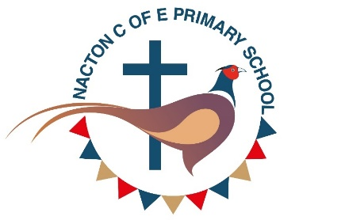
Report for annual meeting 2024
In September, I started as Headteacher here in Nacton. Initially, this was an acting headship while on secondment from my advisory post with the diocese. However, I quickly realised I did not want to leave and so have made the school my home.
I am learning lots about being the head of a small, rural school. Very different from the urban schools of my past. But there is something magical here I think. With every staff member knowing every child and every child knowing one another well. Relationships are really strong and the staff have been very welcoming to both myself and other new members of staff.
A lot of work has gone into improving the grounds. Several skips filled with rubbish have come and gone. Walls have been repainted and grants won to replace some of the worn-out resources for our youngest learners. The library has been audited with outdated stock removed to make space for texts with greater diversity. The oldest book we found was a poetry book from 1967. We also found the original Bible for Nacton and Levington school from 1840.
Numbers have dipped and recovered over the year. We started with 93 children in September and still have 93 with a few changes in individuals. The school still has four classes. Three are mixed ages (Y1/2, Y3/4 and Y5/6). We offer 14 spaces in each year group. Less than a third of our children come from the village.
A significant piece of work this year has been reviewing our whole school curriculum. This has been to ensure we are compliant with the National Curriculum. This has been published on our website here https://www.nacton.suffolk.sch.uk/curriculum/
We teach the curriculum through enriching activities. So far this year our reception class, Tigers, have particularly enjoyed visits from the police and fire brigade as part of their learning about the emergency services. They’ve also enjoyed a recent visit to Easton Farm and Home Farm Nacton. Lions class are off to Framlingham castle next week. Leopards class have enjoyed learning about Stonehenge and have made both pizza and pasta this year. Jaguar class enjoyed their bikeability lessons learning to be safe on the roads.
You will also notice that we have updated the school logo. This still proudly displays elements of the old logo with the pheasant and the bunting but some additions serve to clearly identify us as a church school.
Gemma Taylor
Headteacher

